Digital Dining with Zoom

**Table of Contents:**

A: The Pre-requisites

Access to the Internet

A device that can connect to the internet

The Zoom desktop program or mobile app installed on your device to connect to a meeting

B: The Set Up

Getting the best experience … on a laptop

Getting the best experience … on an Android tablet

Getting the best experience … on an iPad / iPhone

Getting the best experience … on an Android phone

C: Wirelessly connecting to a TV

D: Meeting Feng Shui

Getting your device with the camera in the right place

## 

## A: The Pre-requisites

Before you joint a Zoom meeting you need three things

### Access to the Internet

The best option is to connect to a broadband internet connection that you might have a home or work. You can does this either via WiFi or directly using an ethernet cable

If broadband is not available or is too slow, the second option is to connect to the internet via a mobile network. This is how mobile phones (and some tablets) access the internet when you’re out and about.

Using a mobile network, you can connect directly to a meeting using your mobile phone or tablet (if it is has this functionality) once you have installed the required Zoom app. Alternatively, many modern mobile phones let you share their mobile network connection by creating something known as a ‘hotspot’ (also known as *internet tethering*). This essentially means the mobile phone creates a WiFi network to which other nearby devices can connect. This is particularly useful if you have a laptop that you wish to use to join a meeting as you can turn your phone into a hotspot and then connect your laptop to this, as if you were connecting to a normal WiFi network.

Bear in mind that your mobile phone contract may limit the amount of internet data you can use each month, so check this before joining a Zoom meeting while using a mobile network or using your phone as a hotspot. Also, your phone battery will drain quicker if being used in this way.

### A device that can connect to the internet

Providing they can connect to the internet, you can use any of the following devices to join a Zoom meeting : PC or laptop; (both require Zoom to be downloaded - this is a quick and simple process. Your PC or laptop will also require a webcam); Mobile phone or tablet (there are apps for Android phones and tablets, as well as ones for iPhones / iPads). These apps need to be installed in order to join a meeting

Close down any programs that you are not using so your device has to deal with fewer processing tasks

### The Zoom desktop program or mobile app installed on your device to connect to a meeting

If you are using a PC or Laptop you can download the program you require to join a meeting by going to the Zoom website via this link <https://zoom.us/download#client_4meeting> and clicking on the ‘Download’ button below the ‘Zoom Client for Meeting’ heading

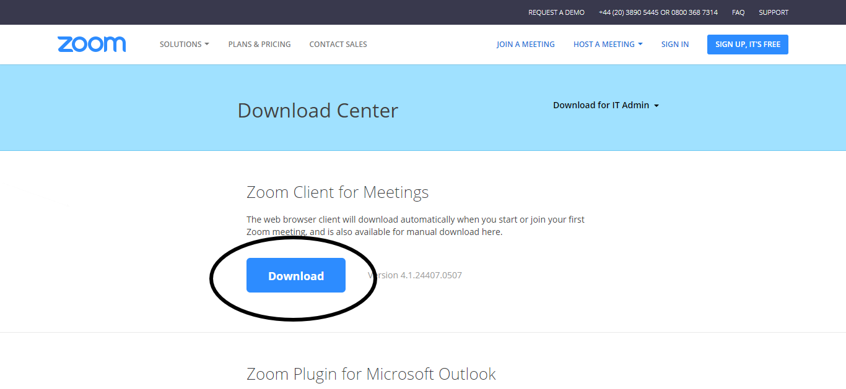

If you haven’t done this before a meeting starts, the program will automatically download and install when you go to join the meeting.

If you are using an iPhone or an iPad you can install Zoom from the App Store (you need to have an App Store account - which is free)

<https://itunes.apple.com/us/app/id546505307>

If you are using an Android phone or tablet (most phones / tablets which are not iPhones or iPads run the Android operating system) you can install Zoom from Google Play (you need to have a Google account - which is free)

<https://play.google.com/store/apps/details?id=us.zoom.videomeetings>

The steps above will allow you to connect to a Zoom meeting, but this is just half the battle for getting a worthwhile experience. Remember, the other groups joining a meeting need to be able to see/hear you clearly and everyone in your own group needs to be able to comfortably see/hear the other groups joining the meeting. So

* Make sure the device you are using to connect to the meeting is positioned in such a place to get all your lovely faces on the camera
* Make sure the device you are viewing the other groups connecting to the meeting on is larger enough for you to see these groups clearly



As you can see from the diagram above, the best viewing experience is going to come from a larger screen, with seats positioned

## B: The Set Up

### Getting the best experience … on a laptop

**Video Quality - Use an external webcam**

The built-in webcam on your laptop is probably adequate, but no better. So you should consider attaching an external webcam, such as the Logitech c920. Not only will this give you a better image and audio (if you do not use a separate microphone), an external webcam can be more flexibly positioned as it is only attached to your laptop by a wire

**Audio Quality - Use an external microphone**

The sound from most devices that can easily connect to a video meeting is poor. The built-in microphones are generally designed to pick up sound from nearby and so capturing a number of people talking from further away will introduce echo and background hiss. External microphones can significantly improve the quality of the sound from your ‘side’ of the meeting - so far, a set up using a Zoom H1 record with a Rode Videomicro has worked very well. However, this is a set up used as it was available and is not specifically designed for use with laptops, PCs etc. A better option would be to use a plug-in USB microphone marketed for use in video calling / podcasting.

Regardless of the microphone you are using, the further away the mic is from the people talking, the lower the audio quality will be, so consider a microphone with a decent length cable.

**Audio Quality - Use external speakers**

As with built-in microphones, built-in device speakers are often poor and turning up the volume to better hear other groups in the meeting may produce a tinny, distorted sound. External speakers, whether plug in or Bluetooth will help to give you a more audible meeting.

**Increasing the screen size - connecting to a TV**

Modern laptops can be connected to most modern TVs using an HDMI cable

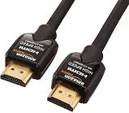

Apple laptops can be connected directly using an HDMI cable (if they have an HDMI port) or by using Mini DisplayPort to HDMI Cable adapter and then connecting this to the TV with an HDMI cable

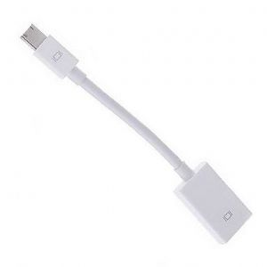

Older laptops with HDMI ports can usually be connected using a VGA cable.

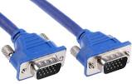

Once you have connected your laptop, use the TV remote to select the ‘Source’ which corresponds to where you the laptop plugged into (*TVs normally have between 5 and 10 sources - this is basically the number of outlets on a TV that you can plug stuff into - so it won’t take too long if you click through them until you see your laptop screen showing on the TV*).

Make sure that you place your laptop on a similar level to the TV and do not obscure the laptop webcam as this will still be used to transmit video of you to other meeting attendees.

You should now be able to view the Zoom meeting on your TV screen. *To connect the laptop to a TV wirelessly, use the instructions from section C.*

### Getting the best experience … on an Android tablet

**Video Quality**

Although technically possible to connect a webcam to some tablets, you will be best served using the tablet’s built-in camera.

**Audio Quality - Use an external microphone**

Plug a tablet / smartphone specific microphone into the headphone jack on your device or use a DSLR microphone with a trs to trrs adapter

(extension cables can allow you to move the mic closer to the discussion)

**Audio Quality - Use external speakers**

As with built-in microphones, built-in device speakers are often poor and turning up the volume to better hear other groups in the meeting may produce a tinny, distorted sound. External speakers, whether plug in or Bluetooth will help to give you a more audible meeting.

**Increasing the screen size - connecting to a TV**

If you’re tablet has an HDMI port (usually a mini) you should be able to connect it to the TV using a similar process to above - although you will need a mini to full size HDMI cable in this instance.

Once you have connected your tablet, use the TV remote to select the ‘Source’ which corresponds to where you the laptop plugged into (TVs normally have between 5 and 10 sources - this is basically the number of outlets on a TV that you can plug stuff into - so it won’t take too long if you click through them until you see your laptop screen showing on the TV)

Make sure that you place your tablet on a similar level to the TV and do not obscure the tablet’s camera as this will still be used to transmit video of you to other meeting attendees.

You should now be able to view the Zoom meeting on your TV screen. *To connect the tablet to a TV wirelessly, use the instructions from section C.*

### Getting the best experience … on an iPad / iPhone

**Video Quality**

Use the iPad’s built-in camera.

**Audio Quality - Use an external microphone**

Plug a tablet / smartphone specific microphone into the headphone jack on your device or use a DSLR microphone with a trs to trrs adapter

(extension cables can allow you to move the mic closer to the discussion)

**Audio Quality - Use external speakers**

As with built-in microphones, built-in device speakers are often poor and turning up the volume to better hear other groups in the meeting may produce a tinny, distorted sound. External speakers, whether plug in or Bluetooth will help to give you a more audible meeting.

**Increasing the screen size - connecting to a TV**

The latest Apple devices can be connected to TVs using a Lightning Digital AV Adapter (<https://www.apple.com/uk/shop/product/MD826ZM/A/lightning-digital-av-adapter?afid=p238%7CsL4w7cF5j-dc_mtid_187079nc38483_pcrid_104154899041_&cid=aos-uk-kwgo-pla-btb--slid-----product-MD826ZM/A-UK>)

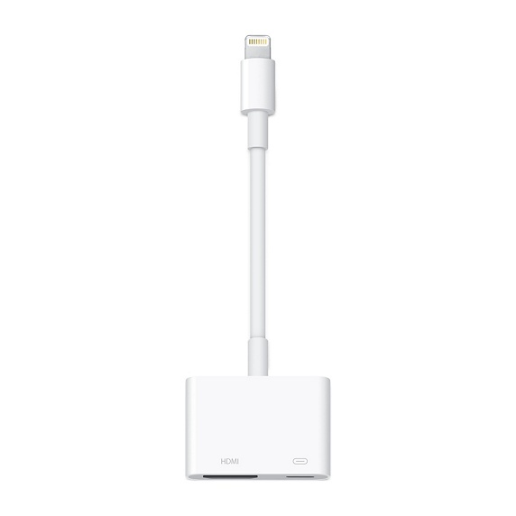

Which is then connected to the TV with a standard HDMI cable.

Once you have connected your iPad use the TV remote to select the ‘Source’ which corresponds to where you plugged the iPad into (TVs normally have between 5 and 10 sources - this is basically the number of outlets on a TV that you can plug stuff into - so it won’t take too long if you click through them until you see your laptop screen showing on the TV)

Make sure that you place your iPad on a similar level to the TV and do not obscure the tablet’s camera as this will still be used to transmit video of you to other meeting attendees.

You should now be able to view the Zoom meeting on your TV screen.

*To connect the iPad to a TV wirelessly, you can use the instructions from section C or - if you have Apple TV - use the built in screen mirroring functionality.*

### Getting the best experience … on an Android phone

**Video Quality**

Use the built-in camera.

**Audio Quality - Use an external microphone**

Plug a tablet / smartphone specific microphone into the headphone jack on your device or use a DSLR microphone with a trs to trrs adapter

(extension cables can allow you to move the mic closer to the discussion)

**Audio Quality - Use external speakers**

As with built-in microphones, built-in device speakers are often poor and turning up the volume to better hear other groups in the meeting may produce a tinny, distorted sound. External speakers, whether plug in or Bluetooth will help to give you a more audible meeting.

**Increasing the screen size - connecting to a TV**

*Due to the variations in Android phones, there are several methods to connect using a cable which may work. However, to ensure greatest compatibility, follow the instructions in section C to wirelessly connect to your TV.*

## C: Wirelessly connecting to a TV

A common option for connecting devices wirelessly to a TV is using Chromecast, which is a small ‘dongle’ that plugs into an HDMI outlet on your TV. Please note that a Chromecast needs power to work, so you can either plug its power cable into a USB outlet on your TV (if it has one) or you can plug it in directly to a plug socket (using the sort of USB adapter plugs that most people use when charging their phones)

<https://store.google.com/product/chromecast_2015>

You also need to download the Google Home app for your mobile device in order to connect the Chromecast (make sure the Chromecast is plugged in, the TV is on and you have selected the corresponding ‘Source’) to your WiFi network

<https://play.google.com/store/apps/details?id=com.google.android.apps.chromecast.app&hl=en_GB>

<https://itunes.apple.com/us/app/google-home/id680819774?mt=8>

Once Chromecast is configured you can ‘cast’ your mobile device to the TV so you will see everything from your mobile screen on the larger screen. You can also cast your laptop screen using the Chrome web browser.

Some modern TVs also come with a built-in wireless display option that can let you connect wirelessly to PCs / laptops running Windows 10 (and some phones) without having to use a Chromecast. This can be hit or miss and should not be relied upon unless you have previously tried it out with the devices you will be using for the Zoom meeting.

Also, check if your ... TV supports Miracast / no longer supported in Android 6.0 >

If you are using your TV screen regularly for Zoom meetings and also want a little bit more flexibility, it may be worth investing in an Android TV box and a supported webcam (most newer Logitech webcams support Android and does this one from Aukey <https://www.amazon.co.uk/Aukey-Microphone-Recording-Compatible-Windows-black/dp/B0721MKXQ2/ref=sr_1_1_sspa?s=electronics&ie=UTF8&qid=1527067418&sr=1-1-spons&keywords=android+webcam&psc=1>)

Android TV boxes are essentially set-top TV boxes that can run most Android apps (such as Zoom) on your TV screen. As they do not have a built-in webcam / camera, in order to use Zoom properly you would need to plug a separate webcam into the Android TV box

## D: Meeting Feng Shui

### Getting your device with the camera in the right place

If you need to include a wide area in your meeting, ideally the device hosting the meeting (ie the one with the camera recording your location) should be in the corner of the room pointing diagonally across the scene. In the diagram below, a camera with a 90 degree viewing angle (which is as wide as most webcams will get) is able to include the full width of the room.





Trying this wide scene set up with the camera on the wall parallel to the subject visually cuts off significant parts of the left and right sides.

The main drawback of trying to include a wide scene in your meeting is that the device camera will be further away from the subject. Not only will this reduce size of people in the scene, but also potential ‘cosiness’. Also, if you are using the device microphone for audio, this will similarly be further away from the action, so reducing sound quality.